Project Design Phase
Solution Architecture

Solution Architecture:
Solution Architecture bridges the gap between business challenges and technical implementation.
In this project, the architecture eliminates manual paperwork through a
3-tier cloud-based structure, where:
- Data is entered through UI forms
- Processed via Client Scripts
- Stored in a centralized relational database
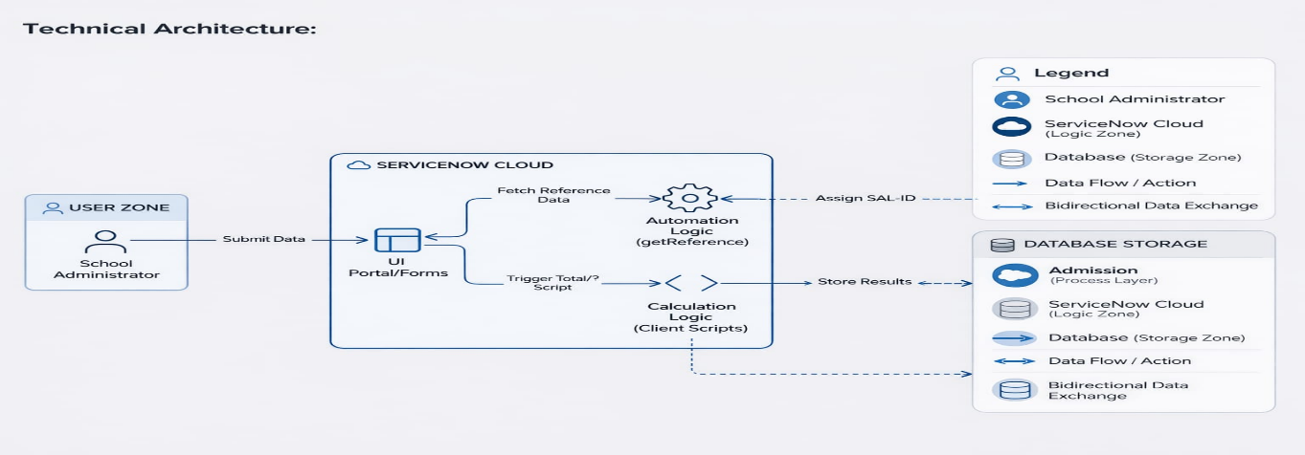
Solution Architecture Diagram:

The architecture bridges the business problem of manual paperwork by using a 3-tier cloud structure. Data submitted via UI forms is processed by automated Client Scripts and synchronized with a MariaDB-based Salesforce Master Registry
Component | Technical Role
ServiceNow Instance | Cloud-based platform hosting application logic and database.
Custom Tables | Core data structures including Master (Salesforce), Admission, and Student Progress tables.
Client Scripts | JavaScript logic handling auto-population, total calculation, percentage computation, and result generation.
Process Flow | Visual tracker displaying student admission stages (New —> Joined —> Closed).
UI Forms | Customized digital forms for structured data entry.
Update Sets | Deployment mechanism to migrate configurations across instances.

